Solution:
1.
I suggest choosing Agile methodology, because:
- Reliability: requirements are quite clear by the college.
- Type of requirements: includes functional requirements and non-functional requirement
- The benefit of Agile over waterfall is the ability to change dynamically to the customer's wants and needs
- User involvement in the situation: large because GarageOne focuses on automated communication with their customers in which a simple application is used to interact and inform their customers.
- Team size: Small: 3 developers and 1 tester can easily use the process without any work pressure. So, Agile method is also good here to improve cross training and team working.
- The software development methodology I suggest for this situation is AGILE
this is a new and big project, so it needs brain-storming, user surveys, changed many times; need to get feedback continuously after each time cycle to make adjustments. Also, to ensure the project is completed on time and within budget. The benefit of agile over waterfall is the ability to change dynamically to the customer's wants and needs. A focus on the features that are the highest value to the customer. So our new service could be stable, secure, and ease to use.

2.
+ 4 functional requirements system handler:
- System can send a personalized digital invoice with their branding.
- Send live service updates.
- System can send automatic vehicle service reminders.
- Send automatic service feedback and auto‘post them on all Google listings.
+ 2 non-functional requirements of system:
- System can Automatic interaction via SMS, Email, WhatsApp, Zalo.
- GarageOne focuses on automated communication with their customers in which a simple application is used to interact and inform their customers.

3. 2 user stories of customer:
- As a customer, I want to can choose many services to book combining with date, type of car and required workers.
- As a customer, I want to interacts with consultants to get further information through SMS, WhatsApp, Zalo, Email.

4. Story map
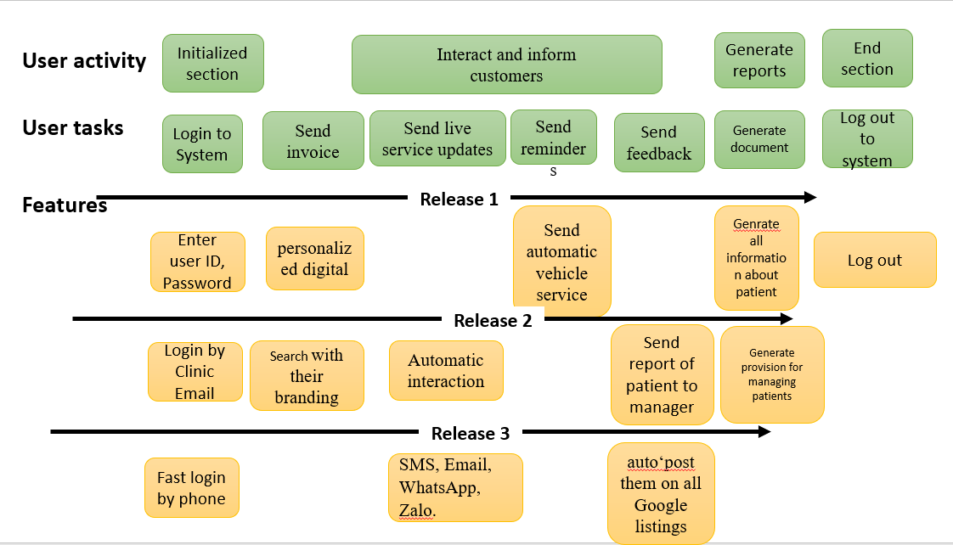

5.
a. I agree with this require that I will choose AGILE to develop this application because:
Since the requirements system is flexible and subject to change at any time, it is appropriate to deploy the system first rather than developing it in stages. The size is pretty small compared to the the normal standards of such project. Agile is a much more team-based model than Waterfall, Agile is also good here to improve cross training and team working and therefore suits the teams.

